DCC-GARCH correlation: AUDUSD and NZDUSD
Method 09 / GARCH(1,1) + Engle DCC / Alpari D1 full available history

Study setup
Logical pair: AUDUSD , NZDUSD
Broker symbols: AUDUSD_i , NZDUSD_i
Snapshot: 2026-11-03_majors_alpari_D1
Timeframe: D1
Matched return window: 1999-01-05 to 2026-11-02 (UTC bar dates)
Matched return count n: 7202
Dropped unfinished last bar dated 2026-11-03 UTC after a tick-volume check against the prior complete day.
AUDUSD GARCH(1,1): mu=0.000030, omega=0.005430, alpha=0.052173, beta=0.937170
NZDUSD GARCH(1,1): mu=0.000000, omega=0.004929, alpha=0.040694, beta=0.950325
DCC: a=0.021076, b=0.975685, a+b=0.996761
Burn-in ignored in path summaries and chart: first 60 updates
Complete matched rows (Excel): AUDUSD-NZDUSD_DCC_D1.xlsx
Complete matched rows (HTML table): AUDUSD-NZDUSD_DCC_D1_data.html

Method carried forward
DCC-GARCH first fits a constant-mean GARCH(1,1) on each matched daily log return of close, ln(close_t / close_t-1), then updates Engle (2002) dynamic conditional correlation on the standardised shocks z = residual / conditional sigma. Quotes are not inverted. Correlation targeting sets Q_bar to the sample correlation of z; a and b are estimated by maximising the bivariate Gaussian DCC likelihood with a >= 0, b >= 0, and a + b < 1. Path summaries ignore the first 60 updates. The headline is rho on the last day. Same-sample Pearson r on log returns is a side check only. A high |rho| does not prove cause, lead-lag, or a trading signal.

Results
Latest DCC rho: 0.616507
Post-burn-in path (n=7142): mean=0.808094, median=0.822837, min=0.482230, max=0.939268, std=0.077842
Share of post-burn-in days with |rho| >= 0.4: 100.00%; |rho| >= 0.7: 90.17%
Same-sample Pearson r: 0.828722
Latest rho minus r: -0.212214

Conclusion
Over 7202 matched daily log-return rows for AUDUSD and NZDUSD (broker quote directions unchanged), latest DCC rho is 0.6165 (positive, moderate conditional linear link in this sample) with fitted a=0.0211, b=0.9757 (a+b=0.9968). After a 60-day burn-in, path mean is 0.8081 and std is 0.0778. Same-sample Pearson r is 0.8287 (latest rho minus r = -0.2122). This does not establish cause, lead-lag, or a lasting trading rule.

Charts
Daily closes

Daily log returns
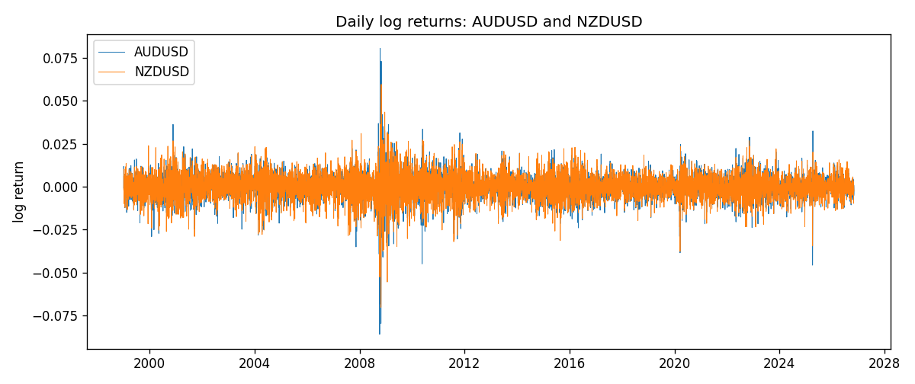
DCC rho path with Pearson r reference
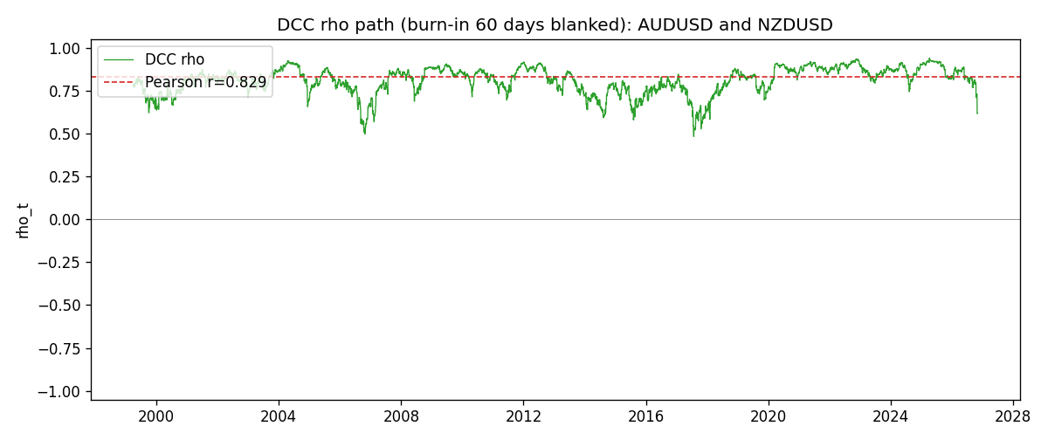

Data report
Every matched row that entered the DCC recursion is stored in the sibling Excel workbook named AUDUSD-NZDUSD_DCC_D1.xlsx. Embedding all rows as a Word table is impractical at this length; the Word file holds the column list, column summaries, and the first and last 15 matched rows.
Columns: time, AUDUSD_open, NZDUSD_open, AUDUSD_high, NZDUSD_high, AUDUSD_low, NZDUSD_low, AUDUSD_close, NZDUSD_close, AUDUSD_tick_volume, NZDUSD_tick_volume, AUDUSD_spread, NZDUSD_spread, AUDUSD_real_volume, NZDUSD_real_volume, AUDUSD_log_return, NZDUSD_log_return, AUDUSD_sigma, NZDUSD_sigma, AUDUSD_z, NZDUSD_z, q11, q22, q12, rho_t
Column summaries (matched calculation rows)
column | count | mean | std | min | 25% | 50% | 75% | max
AUDUSD_open | 7202 | 0.75190973 | 0.13530408 | 0.4785 | 0.6610275 | 0.731395 | 0.8089525 | 1.10284
NZDUSD_open | 7202 | 0.65620671 | 0.10825448 | 0.3913 | 0.5910925 | 0.6683 | 0.724695 | 0.88218
AUDUSD_high | 7202 | 0.75595988 | 0.13586572 | 0.4878 | 0.6647 | 0.734725 | 0.81501 | 1.10795
NZDUSD_high | 7202 | 0.66012182 | 0.1087492 | 0.3961 | 0.5946275 | 0.67189 | 0.7292675 | 0.88421
AUDUSD_low | 7202 | 0.74785283 | 0.13461673 | 0.4775 | 0.6577 | 0.727385 | 0.8042 | 1.0975
NZDUSD_low | 7202 | 0.6525168 | 0.10784895 | 0.3897 | 0.587955 | 0.66406 | 0.72082 | 0.87988
AUDUSD_close | 7202 | 0.75195766 | 0.13528533 | 0.4786 | 0.6611925 | 0.731645 | 0.809065 | 1.10169
NZDUSD_close | 7202 | 0.65627751 | 0.10825012 | 0.3907 | 0.59141 | 0.668305 | 0.7249175 | 0.8822
AUDUSD_tick_volume | 7202 | 77337.3 | 138128.78 | 109 | 5435.5 | 43320 | 71312.25 | 1234623
NZDUSD_tick_volume | 7202 | 68561.899 | 123036.41 | 17 | 5505.5 | 33822 | 58470.25 | 1127682
AUDUSD_spread | 7202 | 30.821161 | 16.887481 | 0 | 13 | 30 | 50 | 50
NZDUSD_spread | 7202 | 30.366287 | 25.672101 | 0 | 9 | 17 | 50 | 80
AUDUSD_real_volume | 7202 | 5.2413627e+09 | 1.253718e+11 | 0 | 0 | 0 | 0 | 3.811512e+12
NZDUSD_real_volume | 7202 | 1.6659405e+10 | 8.488719e+10 | 0 | 0 | 0 | 0 | 2.705649e+12
AUDUSD_log_return | 7202 | 2.237e-05 | 0.00754318 | -0.08602525 | -0.00386318 | 0.00028132 | 0.00415217 | 0.0806166
NZDUSD_log_return | 7202 | 5.13e-06 | 0.00764596 | -0.07027433 | -0.00426304 | 0.00021271 | 0.00457975 | 0.05966839
AUDUSD_sigma | 7202 | 0.00693968 | 0.00278727 | 0.00391444 | 0.00551772 | 0.00627227 | 0.00757821 | 0.03848892
NZDUSD_sigma | 7202 | 0.00728885 | 0.00217006 | 0.0043896 | 0.00595853 | 0.00670835 | 0.00804048 | 0.02523575
AUDUSD_z | 7202 | -0.00457153 | 1.0001113 | -8.4724828 | -0.60568982 | 0.04075301 | 0.63744083 | 5.0250661
NZDUSD_z | 7202 | -0.00236257 | 1.0000743 | -5.6199003 | -0.6319842 | 0.03228626 | 0.64637265 | 4.2143706
q11 | 7202 | 1.001531 | 0.18614973 | 0.63282885 | 0.88586059 | 0.97703947 | 1.0766594 | 2.4482023
q22 | 7202 | 1.00149 | 0.16851392 | 0.6546758 | 0.88651591 | 0.97303805 | 1.0801322 | 2.1664839
q12 | 7202 | 0.81189221 | 0.17948697 | 0.42297596 | 0.70180551 | 0.7927808 | 0.88734047 | 1.9498614
rho_t | 7202 | 0.8078332 | 0.07761368 | 0.48222953 | 0.76442349 | 0.8220115 | 0.86683973 | 0.93926832
First 15 matched rows (selected columns)
time | AUDUSD_log_return | NZDUSD_log_return | AUDUSD_sigma | NZDUSD_sigma | AUDUSD_z | NZDUSD_z | q11 | q22 | q12 | rho_t
1999-01-05 | -0.00080418179 | -0.0018597736 | 0.0062628742 | 0.0058824177 | -0.1331909 | -0.31621006 | 1 | 1 | 0.80986441 | 0.80986441
1999-01-06 | 0.011836351 | 0.0020455609 | 0.006110525 | 0.0057894367 | 1.9321375 | 0.35327356 | 0.97929774 | 0.98103124 | 0.79368324 | 0.80974526
1999-01-07 | 0.0088650256 | 0.0062963171 | 0.0065427781 | 0.0057022502 | 1.3503514 | 1.1041275 | 1.0374055 | 0.96304667 | 0.79139388 | 0.79176217
1999-01-08 | 0.00031515916 | -0.00055396548 | 0.0066883376 | 0.0057451171 | 0.042638858 | -0.096476972 | 1.0538511 | 0.96856294 | 0.80619787 | 0.79797282
1999-01-11 | 0.0072213815 | 0.010290425 | 0.0065169405 | 0.0056455399 | 1.1034941 | 1.8226989 | 1.0315039 | 0.94844737 | 0.78913151 | 0.79782444
1999-01-12 | -0.0048608485 | -0.0053157489 | 0.0065607399 | 0.0059237343 | -0.74546844 | -0.89741617 | 1.0353261 | 0.99864457 | 0.81495805 | 0.80147726
1999-01-13 | -0.0078902098 | -0.0099742238 | 0.0064907561 | 0.0059152652 | -1.2202255 | -1.6862354 | 1.0251035 | 0.99457518 | 0.81186522 | 0.8040467
1999-01-14 | -0.002696916 | -0.00018564931 | 0.0065801738 | 0.0061476598 | -0.41441035 | -0.030248148 | 1.0347983 | 1.0335586 | 0.83811376 | 0.81041518
1999-01-15 | 0.007123101 | -0.00074294208 | 0.0064427651 | 0.0060341167 | 1.1009442 | -0.1231743 | 1.0164955 | 1.0116858 | 0.82062224 | 0.80922208
1999-01-18 | 0.00094592471 | -0.0018597736 | 0.006486075 | 0.0059259758 | 0.14121771 | -0.3138858 | 1.0205642 | 0.99064526 | 0.80043375 | 0.79606062
1999-01-19 | 0.0072225153 | 0.0018597736 | 0.006325565 | 0.0058314988 | 1.1370588 | 0.31886616 | 0.99940835 | 0.9718731 | 0.78266001 | 0.79413965
1999-01-20 | 0.0012507819 | 0.0040793678 | 0.0063828549 | 0.0057402661 | 0.19126329 | 0.71060499 | 1.005596 | 0.9536238 | 0.77389425 | 0.79028058
1999-01-21 | 0.00078094498 | 0.0040627941 | 0.0062291159 | 0.0056994529 | 0.12055786 | 0.71278562 | 0.98515478 | 0.94431791 | 0.76056457 | 0.78854184
1999-01-22 | -0.012252745 | -0.012051689 | 0.0060775344 | 0.0056599094 | -2.021004 | -2.1293619 | 0.96474593 | 0.93530372 | 0.74650561 | 0.7858692
1999-01-25 | -0.0039591468 | -0.0035504102 | 0.0065597093 | 0.006070163 | -0.60812495 | -0.58494577 | 1.0306116 | 1.0113638 | 0.8216775 | 0.80482264
Last 15 matched rows (selected columns)
time | AUDUSD_log_return | NZDUSD_log_return | AUDUSD_sigma | NZDUSD_sigma | AUDUSD_z | NZDUSD_z | q11 | q22 | q12 | rho_t
2026-10-13 | 0.0035007712 | 0.0047326165 | 0.0045199707 | 0.0049251544 | 0.76787999 | 0.96084511 | 0.75926396 | 0.74080278 | 0.5954355 | 0.7939388
2026-10-14 | -0.0015193215 | -0.0037306483 | 0.0045075534 | 0.0049453352 | -0.34371141 | -0.75443911 | 0.75646874 | 0.74548711 | 0.59913087 | 0.79782224
2026-10-15 | -0.0075447063 | 0.0047634855 | 0.0044395632 | 0.0049295813 | -1.7061774 | 0.96624422 | 0.74380404 | 0.74259563 | 0.59265137 | 0.79743231
2026-10-16 | 0.0033906408 | 0.0057501001 | 0.0046912516 | 0.00495073 | 0.71636845 | 1.1614033 | 0.79031093 | 0.74745565 | 0.54611838 | 0.71055071
2026-10-19 | 0.0050859986 | 0.0018917133 | 0.0046644791 | 0.0050130219 | 1.0839415 | 0.37729882 | 0.7851494 | 0.76094895 | 0.55299785 | 0.71543392
2026-10-20 | 0.0034620426 | 0.0037199341 | 0.0047188021 | 0.0049518136 | 0.72731733 | 0.75116481 | 0.79406041 | 0.74868571 | 0.55079435 | 0.7143531
2026-10-21 | 0.0036066384 | 0.0030923331 | 0.0046931474 | 0.0049354098 | 0.76210313 | 0.62649855 | 0.78914085 | 0.74561255 | 0.55153956 | 0.71902303
2026-10-22 | -0.0012672558 | -0.0033035227 | 0.0046746354 | 0.0049020581 | -0.27750441 | -0.67396767 | 0.78543288 | 0.73899434 | 0.55081496 | 0.72298723
2026-10-23 | 0.0023765656 | 0.0030929853 | 0.0045945699 | 0.0048758078 | 0.51073106 | 0.63429064 | 0.77119707 | 0.73383812 | 0.54398688 | 0.72311206
2026-10-26 | -0.0032032829 | -0.0028993932 | 0.0045402697 | 0.0048450612 | -0.71212927 | -0.59848557 | 0.76118199 | 0.72771326 | 0.54021064 | 0.72583638
2026-10-27 | 0.0016669876 | -0.00026399852 | 0.0045174455 | 0.0048107715 | 0.36237549 | -0.054940156 | 0.75660111 | 0.72080704 | 0.53868119 | 0.72943873
2026-10-28 | 0.0040915541 | -0.0097283914 | 0.0044506145 | 0.0047423153 | 0.91258814 | -2.0514658 | 0.74421094 | 0.7065832 | 0.5277867 | 0.727828
2026-10-29 | -0.0040915541 | 0.00062190714 | 0.0044684595 | 0.0050711721 | -0.92236041 | 0.12257543 | 0.74690699 | 0.7813408 | 0.47811915 | 0.62586783
2026-10-30 | 0.0010102376 | 0.00019537668 | 0.0044879714 | 0.0049947845 | 0.21841974 | 0.039054871 | 0.74991541 | 0.76589811 | 0.46673401 | 0.61585407
2026-11-02 | -0.0049184984 | -0.0025962955 | 0.0044124302 | 0.0049196522 | -1.121485 | -0.52780185 | 0.73592565 | 0.75054639 | 0.45818833 | 0.61650739

